Introduction to Discrete-Time Signals
and Systems

ECE 340 Lab D51
Riley Dixon - 1425251
Lab performed: October 6th, 2017

Analytic Solutions:
Lab1A Answers:
x1[k] was found to be a periodic function with a period of 20. x1 has an energy of 704.82.
x2[k] however was not found to be periodic. x2 has an energy of 5.2632.

Lab1B Answers:
The energy from the resulting audio file signal was 20,423.
The balia_half.wav file was obtained by taking the first half of the balia.wav's audio samples. The resulting balia.half.wav audio file is simply then justthe first half of the original audio file.

Lab1C Answers:
The lena_bright.jpg image was found to have a lighter tone to the overall appearance of the image. The greyscale of the image was shifted towards white by 30 points.
Original Modified



Lab1D Answers:
Equation: y[k] = x[k] + a*y[k-1]; k < 0 | y[k] = 0
a = 0.5 | a = 2.0
y[0] = 1 | y[0] = 1
y[1] = 1.5 | y[1] = 3
y[2] = 1.75 | y[2] = 7
y[3] = 1.875 | y[3] = 15
y[4] = 1.9375 | y[4] = 31

Any value of (a < 1) will produce a BIBO stable system. However as we approach 1 it will take more samples before we see the system tapering on the graph. The value of a chosen for y[k] was a = 0.75.

Plots
Lab1A:
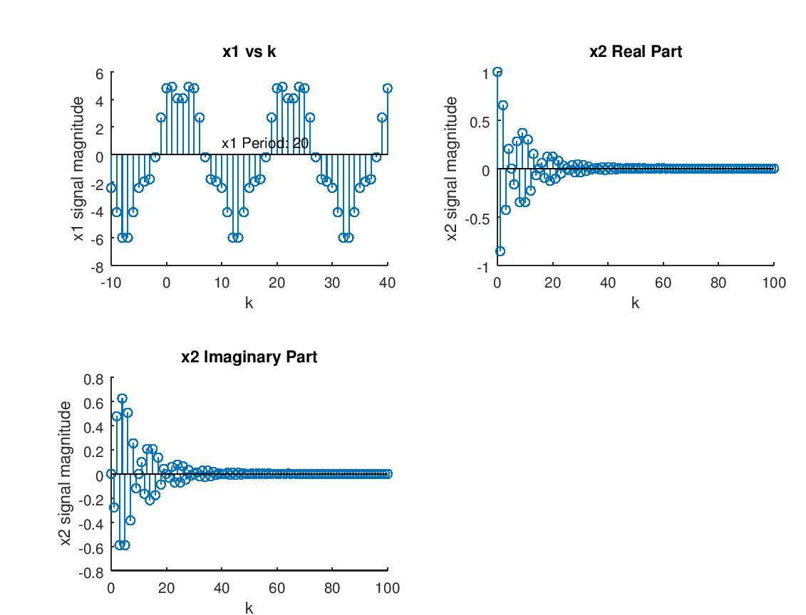

Lab1D:
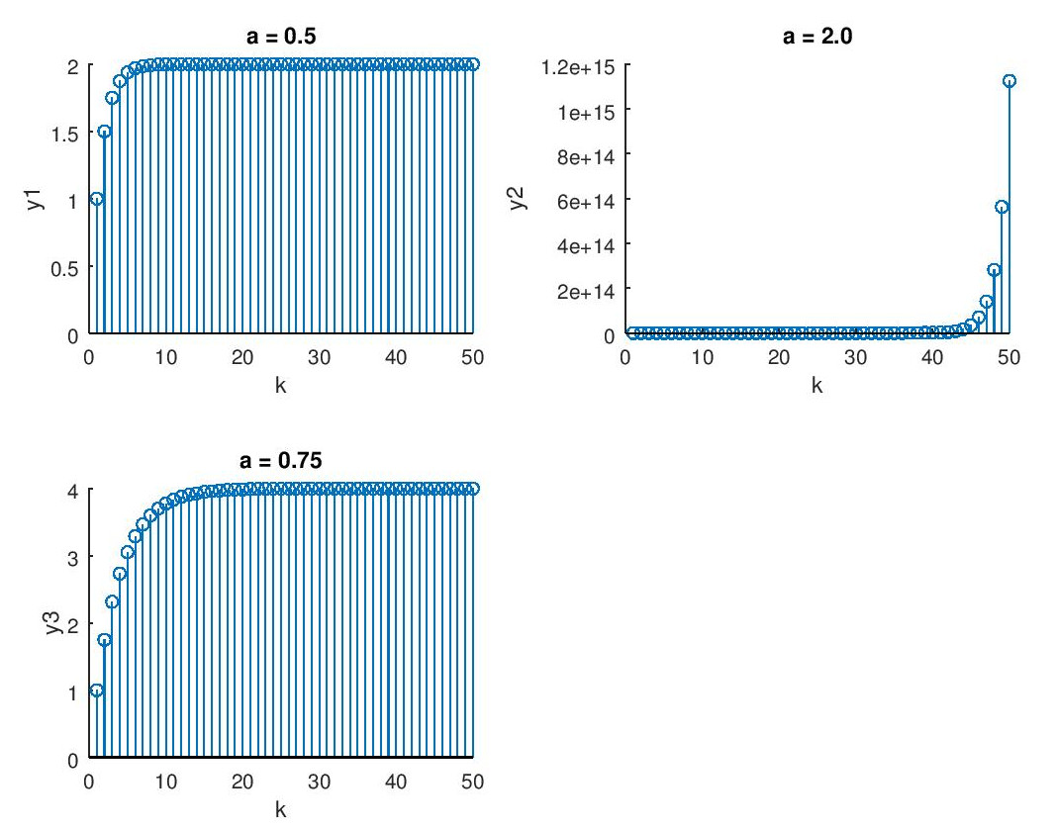
MATLAB Code
----------------------------------------------Lab1A-----------------------------------------
clear;

%Setup the variables used in this lab
k1 = [-10:40];
k2 = [0:100];
x1 = -5.1*sin(0.1*pi*k1 - 3*pi/4) + 1.2*cos(0.4*pi*k1);
x2 = (-0.9).^k2 .* exp(j*pi*k2/10);
x2R = real(x2);
x2I = imag(x2);

%Setup subplot 1 for y1
g = subplot(2,2,1);
stem(k1, x1);
text(10, 1, 'x1 Period: 20');
title('x1 vs k');
xlabel('k');
ylabel('x1 signal magnitude');

%Setup subplot 2 for y2 Real
subplot(2,2,2);
stem(k2, x2R);
title('x2 Real Part');
ylabel('x2 signal magnitude');
xlabel('k');

%Setup subplot 3 for y2 Imaginary
subplot(2,2,3);
stem(k2, x2I);
title('x2 Imaginary Part');
ylabel('x2 signal magnitude');
xlabel('k');

%Calculate signal energy
x1Energy = sum(abs(x1).^2);
x2Energy = sum(abs(x2).^2);

------------------------------------------------Lab1B-------------------------------------
clear;

%Load the music file
filename = 'baila.wav';
x3 = audioread(filename);

%Calculate the energy of the audio file
x3energy = sum(abs(x3).^2);

x3s = x3(1:length(x3)/2);

audiowrite('balia_half.wav', x3s, 44100);

------------------------------------------------Lab1C-------------------------------------
clear;

%Load the image file
filename = 'lena.jpg';
lena = imread(filename);

%Partition the image file into its rows and columns
[lenaRows, lenaColumns] = size(lena);

%Calculate the number of pixels in the image
pixels = lenaRows * lenaColumns;

%Shift the greyscale of the image and save the resulting image
lena_bright = lena + 30;
imwrite(lena_bright, 'lena_bright.jpg', 'jpg', 'Quality', 100);

%The lena_bright image appears to be more white.
%In better words, the greyscale has been shifted towards white by 30
%points.

------------------------------------------------Lab1D-------------------------------------
clear;

%Load the variables used in this lab
%Note MATLAB uses an index of 1, to simplify code the index is not shifted to
%what the actual value of k should be (that is MATLABIndex = k + 1)
a = [0.5, 2];
x = ones(50, 1);

y1 = sysresp(x, a(1));
y2 = sysresp(x, a(2));

%Print the plot for a = 0
subplot(2,2,1);
g = stem(y1);
title('a = 0.5');
ylabel('y1');
xlabel('k');

%Print the plot of a = 2
subplot(2,2,2);
g = stem(y2);
title('a = 2.0');
xlabel('k');
ylabel('y2');

%Does a = 0.75 provide a BIBO stable response?
y3 = sysresp(x, 0.75);

%Print the plot of a = 0.75 to show it is stable
subplot(2,2,3);
g = stem(y3);
title('a = 0.75');
ylabel('y3');
xlabel('k');

------------------------------------------------Sysrep-------------------------------------
function y=sysresp(x, a)
% computes the output in response to an arbitrary input x[n], n=0,N-1
% assume that the system has 0 initial conditions
% input:
% x: the input signal,
% a: the system parameter
% output:
% y: the output signal
N = length(x); % length of the vector
% initialization of the output signal
y = zeros(N, 1);
% the first element in y is y[0], the second is y[1], ...
% note that in Matlab, the vector index starts from 1 and must be a pos. integer
% so the output at time n (y[n]) is the (n+1)th element in the vector y
%y(k) = 0 for values for k < 0;
y(1) = x(1) + a * 0;

%Calculate the rest of the values of y[k]
for k = 2:N
y(k) = x(k) + a * y(k-1);
end

return

